Khan's log
Star date 8/20/14
After about a month of CAD work and consulting with the engineers at NASA Armstrong's 3D printing lab and metal shop we have learned a few valuable lessons. For one thing we learned that the max printing size available to us is 14"x14" which is too small to print the entire chassis out of one piece. We have thus decided to use a multipart frame that can be easily adapted to the design requirements of the as of yet unannounced game. We have also settled upon a name for the new chassis design. This being the fourth rendition of the Kraken chassis, it will be known as the KR4 chassis.
Some features that we are going to implement are as follows:
- Unlike TETRIX metal, we will have full rings of screw holes around every axel hole
- The chassis will be composed of three types of components: nacelles, rails, and cross spars
- The nacelles will be 3D printed out of ABS plastic and will be equipped to move independent of the chassis in order to act as suspension.
- The rails and cross spars will be metal shopped and the rails will be equipped to allow the nacelles to move.
KR4 cross spar KR4 Rail
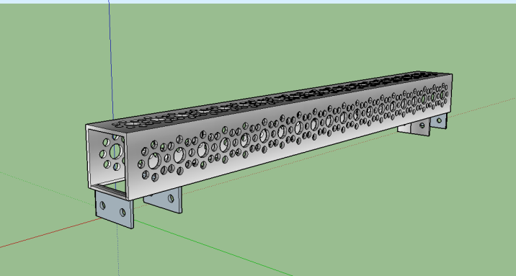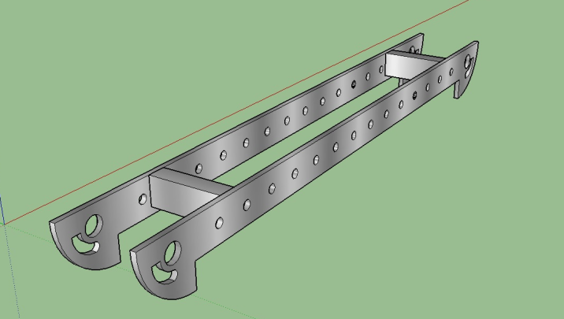
KR4 Nacelle KR4 Chassis
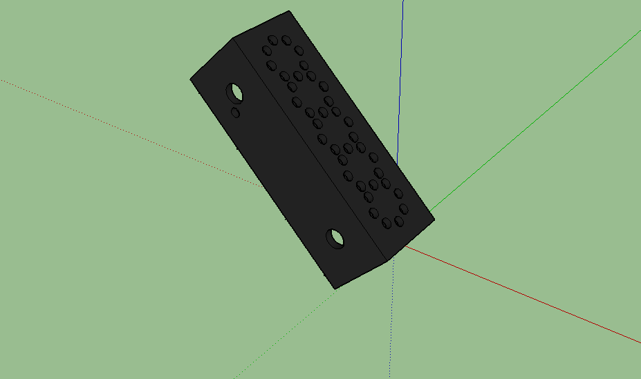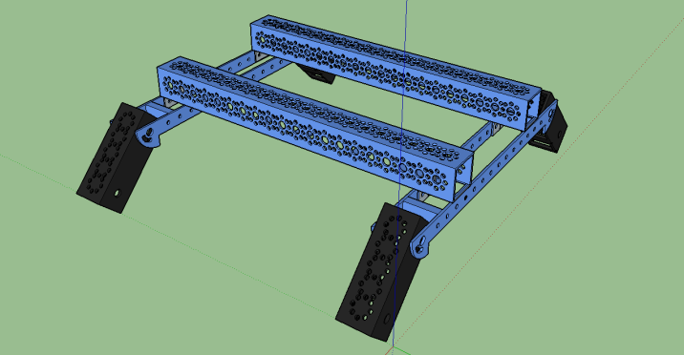

Khan's log
Star date 9/2/14
We are almost ready to begin fabrication on the new KR4 chassis. We have found a converter to change the SketchUp .skp file into the .stl file required by the 3D printer at NASA Armstrong. We have also come upon some design flaws in the KR4 cross spars. The problem we have found in the cross spars is that since they are a closed rectangular tube, there is no way to mount our motor controllers in the compact way that we had originally decided upon. We also have learned that the complex nature of the cross spars will make it difficult for the NASA metal shop to manufacture. To remedy these flaws, we have designed a new system by modifying two 16" TETRIX C-channels and making metal brackets to mount them to the rails.
KR4 bracket.
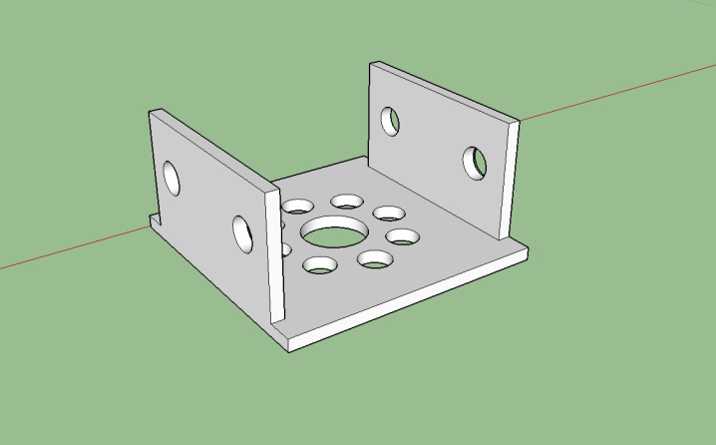

Khan's log
Star date 9/4/14
We have had an epiphany that it would be much easier to have the brackets 3D printed so we have quickly CADed up a new model to be made of plastic.
KR 4 plastic bracket
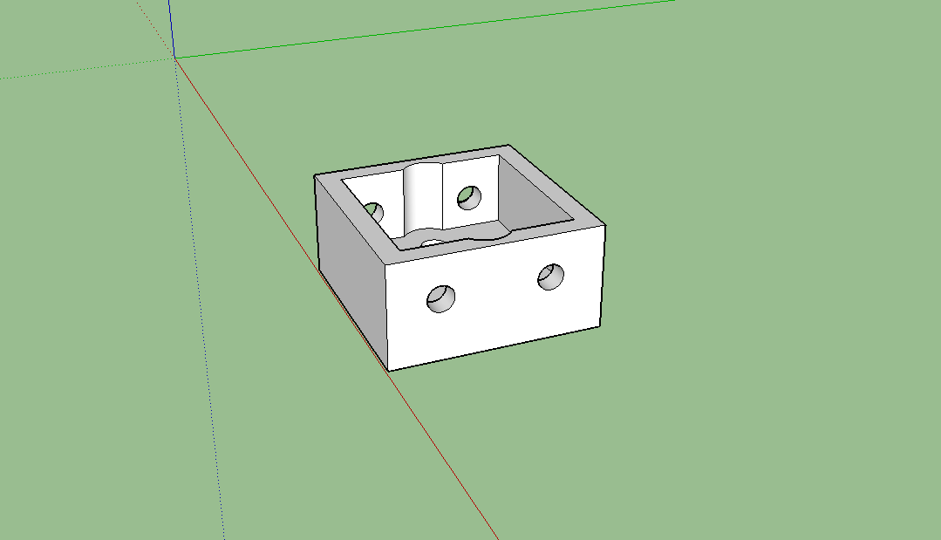

Khan's log
Star date 9/6/14
Today the game was announced and it is called "Cascade Effect". It is played on a normal sized field that is quickly covered in two sizes of whiffle balls that are to be scored in three sizes of tubes.
Some important requirements for the robot are:
- An effective intake for the balls
- A fast lift system
- A system to manipulate and control the rolling goals
- A fast robot to complete the various tasks
- A robot with enough grip to climb the ramps

Khan's log
Star date 9/8/14
Today is our first build meeting of the competition year. We have already brainstormed several ideas for the various elements of the robot.
We have worked out that the intake should require the least amount of accuracy as possible and be able to automatically count the number of balls coming in so as to exceed the limit of five balls. To make counting easier, we have proposed a design that uses a ABS plastic tube with brushes to intake the balls from the ground into the tube. Paddle wheels inside then convey the balls up the tube past an ultrasonic sensor to be counted. Once a ball arrives at the top of the tube, it is stopped by a door until five balls have been taken in. Once the ultrasonic counts five balls, the robot will begin flashing its lights and the intake brush will shut down. The whole tube mechanism is then raised on top of a chain stabilized three stage arm that was used two years ago on our robot in "Ring It Up".

A concept drawing of the "Da Vinci" prototype tube.
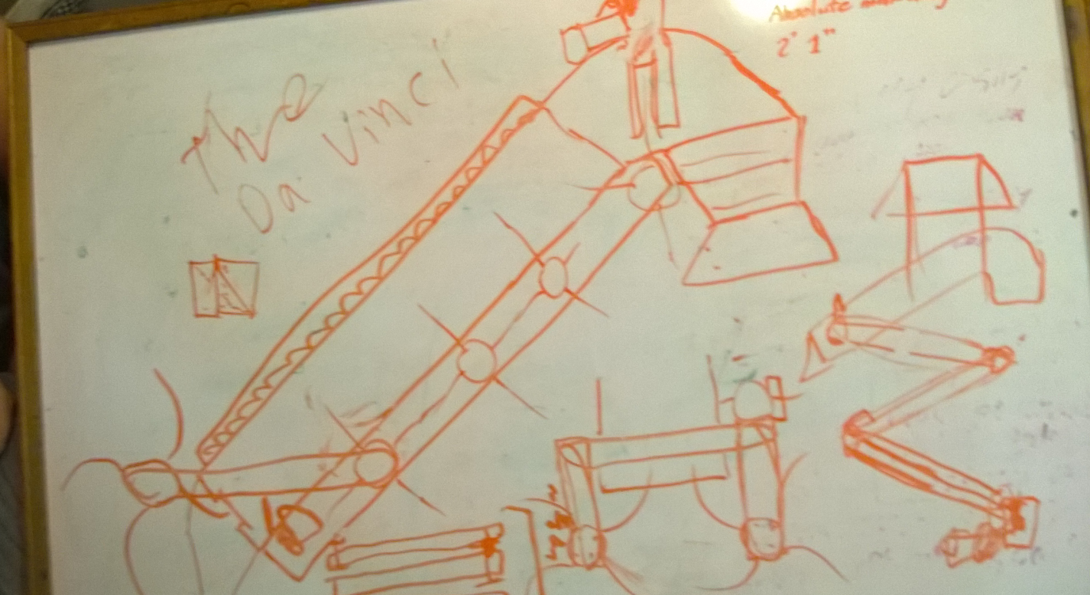
Another accomplishment of tonight's meeting was the completion of our first 3D printed nacelle. We are excited to see how clean it makes the meshing between the two gears and how rigid it is. This is the first 3D printed part that PHI has ever produced and we are excited to see what else we can do. Mk. 1 series KR4 Nacelle
